Word Dictionary App

Created by Harisanker A

Phone: +91-7795438861

Email: harisanker1780@gmail.com

Source code: <https://github.com/harisanker1780/word-dictionary>

**Application Architecture**

Spring Boot App

Angular Client

Dictionary Service

Local File System

File Service

Trie Datastructure

Dictionary Controller

(REST Controller)

Object Mapper

Trie.json

**Angular Client**

This is an Angular Web Application which allows users to upload the text file and user can search words in the upload file using the provided input text field.

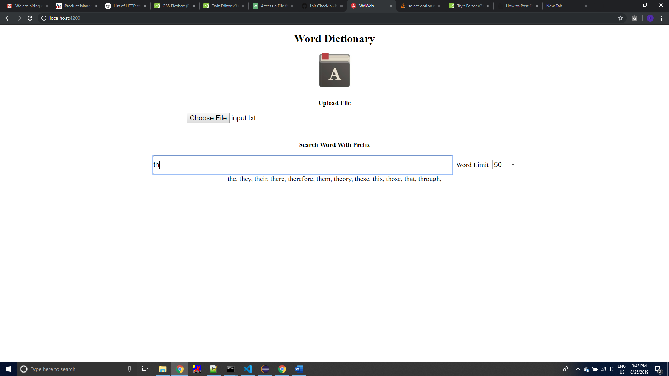

**Spring Boot App**

This is the backend service which provides APIs for uploading the text file and searching the words in the uploaded file.

Internally it uses the trie datastructure, words in the uploaded file will be added to trie and this trie will be converted to a json file using Object Mapper and this json file will be stored in local file system. The same json file will get updated for all the sub-sequent upload file request.

When searching a word, trie object will be created from saved json file using the Object Mapper, and search will be performed on the trie object

**The search API allows you to search using word prefix, e.g. you can search with keyword “th”, this returns the words {“the”, “there”, “that”, “this”, “then”, “theory”,.…}. Also you can set the word limit in the API request so that server will returns only that many words.**

**Upload File Request**

url: http://{baseurl}/dictionary/upload

HTTP Method = POST

Headers = [Content-Type:"multipart/form-data;charset=UTF-8", Accept:"application/json"]

Body = Multipart form data with key ‘file’ and value file content

Response = {"message":"Successfully uploaded the file","success":true}

**Search Word Request(search using word prefix)**

url: http://${baseurl}/dictionary/search/{prefix}?{wordLimit}

HTTP Method = GET

Headers = [Content-Type:"application/json;charset=UTF-8", Accept:"application/json"]

Response = {"matchingWords":["the","they","their","there","therefore","them","theory","these","this","those","that","through"]}

**Test Cases**

Test cases are present at ***word-dictionary-app\wd-service\src\test\java\com\wd\controller\DictionaryControllerTest.java*** and input file for testing is present at ***word-dictionary-app\wd-service\src\main\resources\input.txt***

**Spring Boot Configurations**

Spring Boot Configuration is available at word-dictionary-app\wd-service\src\main\resources\application.properties

Here you can edit the following properties based on your local dev environment.

file.storageDir= D:\\personal\\project\\word-dictionary\\storage

file.allowedExtensions =txt

file.maxSizeInMB=200

**Angular Configurations**

Angular configuration is available at word-dictionary-app\wd-web\src\environments\environment.ts

Here you can edit the following properties based on your local dev environment.

webApiUrl: ‘http://localhost:8080/’

**Source Code**

Source code is available at <https://github.com/harisanker1780/word-dictionary>